How to Enter Progress Marks on ClearTrack for SEIT Services

Please note: Comsewogue and Brentwood are the only districts that currently use ClearTrack.

- ClearTrack website http://cleartrack.esboces.org
- Complete this information to log-in:
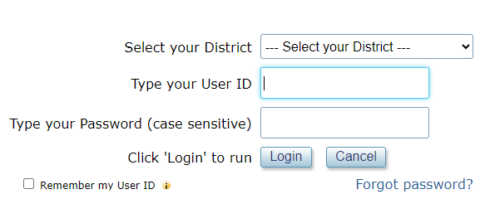
- If you need the User ID and password, email NYTPS SEIT Coordinator, Katie Giordano at katie.giordano@nytps.com).
- Once you log-in, click on:

- Then, click on:
- Choose the student from the list or click “select another student” and click on the student you need.
- There is a “progress note” box under each goal and objective.
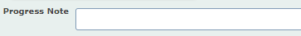
  - Either choose the appropriate progress code from the menu
  - Or
  - Choose the appropriate progress code from the menu AND type additional information such as: how you are working on the goal/objective, how the child is responding, proactive strategies utilized, specific prompts needed, etc.
To choose a progress code, click the paper icon to the right of the progress note box 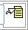 and choose the appropriate code from the menu:
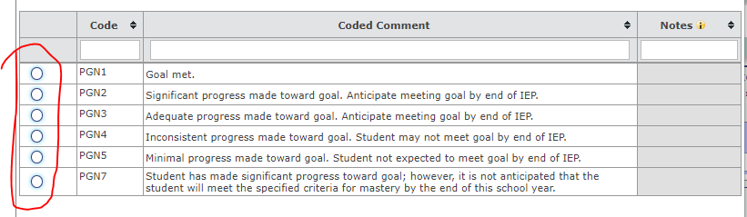

*** A progress note for each goal and objective must be completed.

Click “Save” at the top:
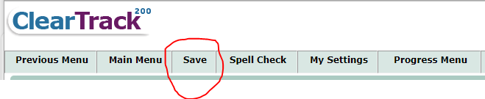
You can print the progress marks from the same progress menu screen by clicking on the printer icon on the top right of the page:
